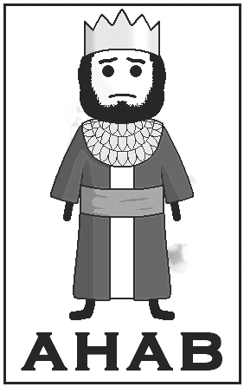
Killed in battle by a random Arrow

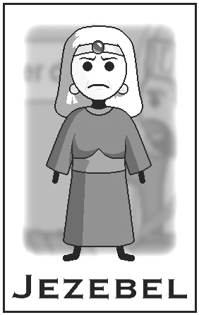
Killed on jehu's orders
Eaten by dogs
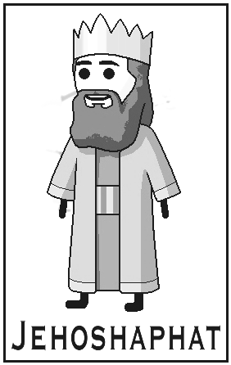
He did what was right in the sight of the lord

God's Justice on the House of Ahab

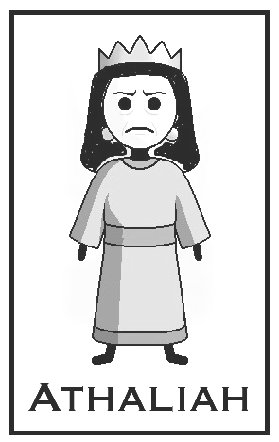
Killed on jehoiada's orders

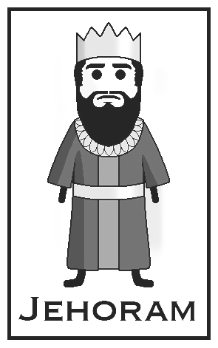
Died of an Incurable disease to no one's sorrow
Killed by jehoram

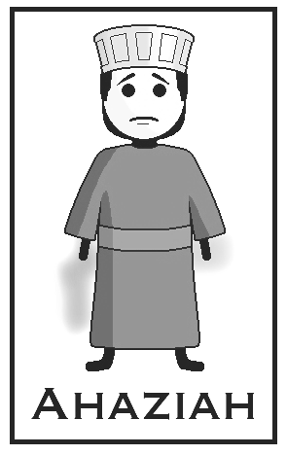
Killed by
jehu's men

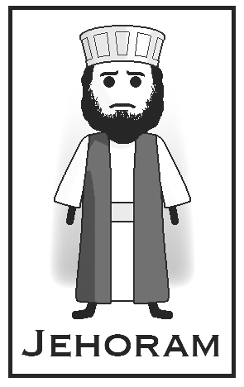
Killed by jehu

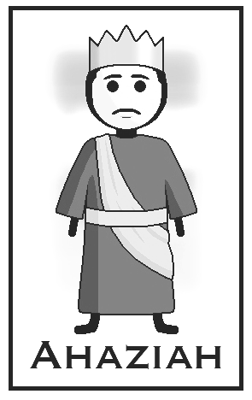
Killed by jehu's men
Taken by Philistines and Arabians

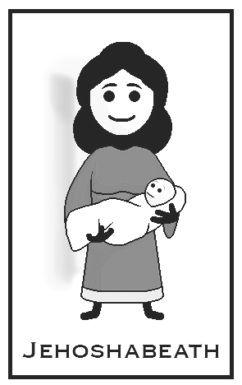
"'For the whole house of Ahab shall perish; and I will cut off from Ahab all the males in Israel, both bond and free."
2 Kings 9:8

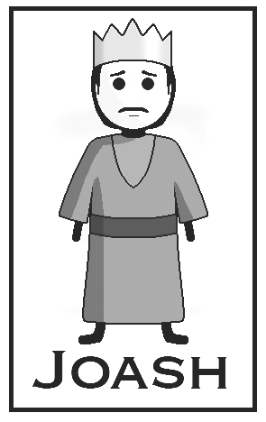
Killed by athaliah

